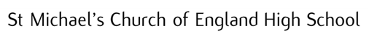
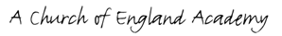

Supplementary Form
Admission to Church of England schools September 2023
To be completed by the parent/guardian

Child’s Surname
Child’s Christian name(s)
Child’s date of birth
Name of parent/carer
Address
Postcode
Telephone
Mobile
E-mail
Are you applying for a place because of:
Special social/medical needs*
Sibling in school – please give their name(s):
Parent/child Faith Commitment
(you may tick more than one box)
If you are applying on faith grounds, please complete the following:
Parent/carer/child regularly attends:
Name of church
Name of vicar/minister
Address of church
Post code
Telephone
Email
(This named person will be contacted in order to verify your church attendance)
Signed: Date:
PLEASE RETURN THIS COMPLETED FORM TO THE SCHOOL NO LATER THAN 31 OCTOBER 2022 admissions@saint-michaels.lancs.sch.uk
*For clarification see oversubscription criteria 1(b) on p2 of the Admissions Arrangements

